Honours Project Final Report
2019-2020
Submitted for the Degree of:
BSc Computer Games (Design)

Project Title: Viability and usability of computer games in diagnosing dementia
Name: Jamie Adam
Programme: BSc Computer Games (Design)
Matriculation Number: S1716162
Project Supervisor: David Moffat
Second Marker: Julie Campbell
Word Count: 9006
(excluding contents pages, figures, tables, references and Appendices)

“Except where explicitly stated, all work in this report, including the appendices, is my own original work and has not been submitted elsewhere in fulfilment of the requirement of this or any other award”

Contents
1. Introduction 4
1.1 Project Background 4
1.3 Project outline 6
1.4 Projects aims and objectives 6
• 1.4.1 Hypothesis 7
• 2.0 Literature Review 8
• 2.1 Research in the use of serious games in mental health 8
• 2.1.1 Use of Serious games in mental health 8
• 2.1.2 Effects of serious games being used in mental health 8
• 2.2 Investigate the different types of dementia 9
• 2.2.1 Types of dementia 9
• 2.2.2 Diagnosing dementia 11
• 2.2.3 Treatments in dementia 11
• 2.2.4 game mechanics for mental health 13
• 3.0 Methods 14
• 3.1 Research method 14
• 3.2 Development of the game 14
• 3.3 Obtain assistance from medical professionals 14
• 3.4 Obtain participants 14
• 3.5 Gather and evaluate the data 15
• 4.0 Development and execution 16
• 4.1 Projects target audiences 16
• 4.2 Technology 16
• 4.3 Design concept 17
• 4.4 Testing 22
• 5.0 Conclusion 24
• 5.1 Possible improvements 25
• 5.2 Conclusion 25
References 26
Appendices 29

Abstract

The accuracy of diagnosing dementia types within a person is a vital necessity in order to identify the correct treatment for the patient. Determining the type of dementia can be difficult due to various factors. Alzheimer can be easily misdiagnosed as the reduction of cortical thickness and hippocampal volume are a normal part of aging not just a symptom of Alzheimer’s disease (Fjell et al., 2014), with definitive diagnosis only being concluded by an autopsy (Nussbaum & Ellis, 2003). Other dementia types may also be misdiagnosed due to similarities in the symptoms of other diseases. Clinical Pick’s (also known as frontotemporal disease) is one that is often associated with other commonly known neurological diseases like Parkinson’s disease (Warren, Rohrer & Rossor, 2013). Other issues that must be noted when trying to diagnosis a dementia type is in the various types of dementia can be divided further into subcategories. Frontotemporal disease is a type of dementia that can be sub-categorised into another 3 types of dementia one being Frontotemporal lobar degeneration which contributes the patient’s loss in memory and loss in the patient’s language and speech skills (Warren, Rohrer & Rossor, 2013). With the increasing use of serious games in mental health treatments and study with examples of using multi-platform adventure games to help in the advancement of understanding spatial navigation an issue commonly found in dementia patients (Hyde et al., 2016). Other examples include Tetris being used to help reduce the symptoms of PTSD. Along with the vast improvement of technologies in aiding those with disabilities such as the use of touch screen controls over the traditional mouse and keyboards and the use of eye tracker equipment to gather more accurate data from its user. With further research, the combination of serious games and the latest technology may possibly be a viable and easily useable piece of equipment in assisting the medical profession in diagnosing dementia in patients.

- Introduction

This section will explain a brief history of serious games to the reader explaining what serious games are, how they are becoming more relevant in the modern age of education and medical care. This section will also explain the various types of dementia and how it is a growing mental health issue in our society. This also gives the reader brief reasoning as to how the two subject matters can possibly be intertwined together giving the reader an overview of the project and its objectives which are going to be achieved through a literature review and the goal objectives to be accomplished through the development of a serious computer game.

  - Project Background

A Serious game is a method in which a game wither that be a board game, card game or computer game is used with a specific intention or purpose, besides entertainment purposes such as education, training and, medical purposes. One prime example of serious games being used in our society is the game tactical Iraqi which was a game designed to help soldiers learn and understand foreign language and culture. This game was studied by the Marine Corps centre for lessons learned (MCCLL) about the effectiveness of the game. The game was examined by having 3 separate battalions use the game before going on tour. By the end of the tours, each of the battalion’s officers concluded that the knowledge received from the game made the soldiers more efficient in understanding and forming relations with the locals (Johnson, 2007). Proving the effectiveness of serious games in education.
The mental disease known as dementia has become one of the biggest mental health issues in the modern world with the number of people affected by it increasing constantly, with one of the biggest factors being old age (Winblad et al., 2016) with no cure within the possible foreseen future the importance of diagnosing dementia at an early stage to slow down the disease’s development within the person is high. Recent studies are showing that the number of people being diagnosed with dementia is doubling every twenty years, with the number of people being diagnosed expected to reach over 131.5 million by the year 2050 (Valladares-Rodriguez et al., 2018) with one of the leading causes of dementia is Alzheimer’s disease (Valladares-Rodriguez et al., 2018) Making Alzheimer disease one of the most relevant threats to mental health (Valladares-Rodriguez et al., 2018). Therefore, making early diagnoses in the disease a priority. Studies were also conducted in Argentina to try and discover the relevance between dementia and old age, the study discovered that an estimated 12.18% of Argentina’s citizens who were over the age of 65 years old were diagnosed with dementia (Rojas et al., 2011) with the number rising to 42.5% of Argentinians being diagnosed with dementia over the age of 80 (Rojas et al., 2011) showing the relevance of age in mental health decay.
However, dementia is not only found in elderly aged. As dementia is classed as a syndrome there can be various types of dementia other than the type found in the previously stated Alzheimer disease that also needs to be taken into consideration such as alcohol-related dementia and vascular dementia which is the result of the brain receiving an insufficient supply of blood, which could a result from minor strokes. Another type of dementia could be frontotemporal dementia where the frontal and temporal lobes of the person’s brain play a factor in the person’s dementia the likes of which can affect people of all ages. In the previous study that was held in Argentina it was stated that out of the 12.18% of the people that were diagnosed with dementia, it was discovered that Alzheimer’s disease made up only 5.85% of these cases and vascular dementia also made up another 3.86% of the cases (Rojas et al., 2011). Other studies that have been taken place in the United Kingdom discovered that 34% of diagnosed dementia cases in younger people was caused by Alzheimer’s disease compared to the 80% contribution found in elderly people (Harvey, Skelton-Robinson & Rossor, 2003). This study also showed findings that the number of dementia cases in the United Kingdom for people between the age of 30 and 64 is estimated to be 18,319 (Harvey, Skelton-Robinson & Rossor, 2003). This sums up to be a rough estimate of 54 cases of dementia found within every 100,000 citizens in the United Kingdom between the ages of 30 and 64 (Harvey, Skelton-Robinson & Rossor, 2003). A similar study was also made in Scotland to try and discover the rate of frontotemporal dementia in the country. According to the findings it was estimated that there were 15.4 cases of frontotemporal dementia found in every 100,000 Scottish citizens between the ages of 45 and 64 (Harvey, Skelton-Robinson & Rossor, 2003). Overall, the studies previously stated explain how dementia syndrome can affect various ages and different ways.
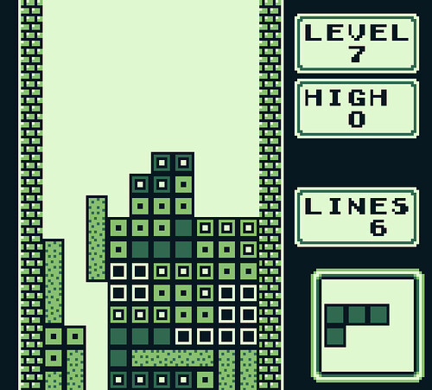
There have already been existing studies in serious games and dementia, not only in the act of diagnosing users but serious games being developed to treat dementia patients. One of the most common and well-known types of a serious game in terms of memory is the computerized cognitive training (CCT) games that are commercially used to try and prevent dementia in its users by strengthening the cognitive function (O’shea, De Wit & Smith, 2019). Providing a prime example where serious games are being integrated into the treatment of dementia. Other studies have also shown that computer games can be used to improve the user’s perception, reactions, problem solving skills as well as improvements to other cognitive functions (McDermott, 2013). Although the study also specifies the importance of the type of game that the user plays as not every computer game can help improve the user’s cognitive functions (McDermott, 2013). Studies have shown that users that play fast action computer games over 10 to 15 hours showed signs of cognitive improvements. However, the same beneficial effects are not found in users who play the same amount in other games like Tetris (McDermott, 2013). This connection in computer games and its effects on the users must be taken into consideration when developing a computer game for dementia.

Figure 1: Tetris, 2008, https://www.flickr.com/photos/conchur/2443635669
  - Project Overview

The aim of this section is to identify the outline of the project and the goals that the project will attempt to achieve at the end. Through the literature review as well as the primary research that will be conducted identifying the hypotheses in a clear manner.
  - Project outline

The overall aim of this project is to critically evaluate wither it is possible to create a computer game that has the potential to diagnose the early stages of dementia in people and if it would become a viable and effective product that can be used in future medical practices. The game will be testing the users on various factors like memory, concentration, sense of touch and awareness and motor function to name a few. The game itself will be a simple easy to play card flipping game as it is important to try and keep the game as simple for the user to play as possible. As the user is playing the game, the game itself will be collecting data and provide a result at the end. The result will then be compared to the result provided by a legitimate medical evaluation.

  - Projects aims and objectives

The main goal of the project is to develop a computer game that can accurately analyse the user and provide a diagnostic on wither the user may or may not have dementia, all while providing a safe and enjoyable experience for the user.
Objectives that will be addressed in the literature review are:
- Examine already existing serious game and their effectiveness

By studying serious computer games that are already being used commercially in the world they can then be compared to their alternative counterparts. This will then lead to a critical analysis of how viable they are and what improvements could have been made. Observing this allows us to determine the viability of serious games compared to other alternatives
- Examine and evaluate existing games that are focusing on dementia in both cases of diagnosing and preventing dementia

Through studying computer games that already exist or are currently in development to assist medical officials in diagnosing or preventing dementia it can help discover useful in game mechanics that help the medical officials determine the diagnostic of the user. As well as in game mechanics that don’t work as well as intended but perhaps maybe altered to and possible implemented to the computer game being created for the project in question.
- Investigate the different types of dementias

As previously stated in the background there are various types of dementia that can affect people in different ways and can also be caused by different varying factors. By studying these various types of dementia in more detail possible connections could be established which will provide useful information on possible ways to diagnose people which can be then used in the game being created for the project.
Objectives that will be completed through the development of the primary research:
- Develop a game that will analyse its player

The goal is to create a game that will collect data and give an accurate diagnostic of its user determining if the user has any signs of dementia. To approach this issue the game will first be developed through storyboarding allowing an early representation of how the computer game will look and feel for its users, this also provides the project will early stage prototypes.
Game engines will also have to be tested and evaluated to determine which game engine would be best for creating the game for the project based on various factors such as knowledge and understanding of the game engine which will contribute to the development time of the game for the project.
When developing the game specific mechanics will need to be implemented in order to test the user mechanics like vibration controls to test the user’s sense of touch as an example. The User interface must also be carefully be developed as the game will be used by various age group it is important that the game is easy to control and understand by making the game itself as simple as possible but still complex enough to test the user. Examples of this are the in-game texts must be large and appropriately coloured to avoid excluding users with visual impairments. Art and sound assets will also have a major factor in the game as it will help the user’s awareness whilst making the game more immersive and enjoyable for the user.
Testing the game will require various testers of various ages and genders. The tests will be conducted in a safe and controlled environment, once all the data is collected it will then be compared to both the literature review and the tests conducted by a medical professional. When all the data is collected and compared the conclusion to wither computer games can accurately diagnose people with dementia and is a more viable option than other alternatives should become apparent.

- 1.4.1 Hypothesis

In order to test the project’s hypothesis, the projects participants will have to take part in two spate tests. First, the participants will play the game created for the project. Once the participants have finished the games play through the data obtained by the game will be given to an examiner to review before the second test. Participants will then participate in a cognitive function pen and paper test conducted by the examiner. By comparing the first test results with the second test the results. The proposed hypothesis for the project is:
The use of serious games can be used as viable assistance for the medical profession in helping the diagnosis of dementia in patients through cognitive function evaluations.
By comparing the similarities in the results of the two tests will provide evidence to the accuracy of the hypothesis.
- 2.0 Literature Review

The literature review is a vital part of the project as it explains the basic amount of knowledge obtained in order to complete the project overall. This knowledge is obtained by looking at existing studies. By doing this they can be evaluated and used as a general guide in proceeding in the project
The literature review will contain research from the following objectives previously explained in the project outline section:
- Research the use of serious games in mental health
- Investigate the different types of dementia
- Game mechanics for mental health

- 2.1 Research in the use of serious games in mental health

- 2.1.1 Use of Serious games in mental health

The use of serious games being used to help citizens with mental health disorders has been steadily on the rise with more serious games being developed. Studies show that the number of serious games being used in health care that are available on the market has increased from 4.7% in the year 2002 to 8.2% in 2011 (Lau, Smit, Fleming & Riper, 2017). Serious games are being developed to help in various fields of mental health such as post-traumatic stress disorder, autism, attention deficit hyperactivity disorder (ADHD) and cognitive function decline (Lau, Smit, Fleming & Riper, 2017). Serious ages are also being used to help people with somewhat self-inflicted mental issues like alcohol use disorder (Lau, Smit, Fleming & Riper, 2017). It must also be stated that the increase in casual gamers allows the use of serious to be implemented more. Studies show that majority of casual gamers are between the ages of 51 and 65 and 30% of gamers between the age of 30 and 50 are also casual gamers (Eklund, 2016). With the number of casual gamers on the rise, the use of serious games is becoming more viable. For example, the mobile mental health game Happify a game that was designed to help reduce stress for the user has been downloaded over 100,000 times on the google play store and is reaching 500,000 downloads (Fleming et al., 2016). However, despite evidence showing serious games having promising results in mental health intervention the adherence and uptake outside of trial settings is still reportingly low (Fleming et al., 2016).
- 2.1.2 Effects of serious games being used in mental health

Serious games as stated previously are being used in various types of metal help it is important to note not just the increase in the number of serious games that are being developed but must also look at the effect they have. One example is a study that was conducted to see if computer games could help people with PTSD. The study had people with PTSD play Tetris in the hope to reduce the symptoms of the disease (Lau, Smit, Fleming & Riper, 2017). The results showed that the game although not initially a serious game did help people with PTSD as it reduced the number of flashbacks that users previously suffered from (Lau, Smit, Fleming & Riper, 2017). Another two studies were also conducted to investigate if serious games can help people with declining cognitive functions, the two studies focused on two different age groups playing the same game. The results showed a positive effect in slowing the decline of the user’s cognitive functions.
Research has also shown that through meta-analyse and systematic reviews computerized therapies delivered to help those from anxiety and depression have been reporting good evidence of effectiveness showing adherence rates between 26% to 76% (Fleming et al., 2016).
Jungmin Kwon’s article “Serious games for job training of persons with developmental disabilities” explains the positives of using serious games (Kwon & Lee, 2016). Serious games can be used to help train people with disabilities in a safe environment as training in the work environment could potentially cause an accident even in the simplest tasks such as dealing with boiling water or using cutlery (Kwon & Lee, 2016). Another positive in serious games is although the game can be very repetitive, it can also be more entertaining and engaging for the user when compared to other treatments (Kwon & Lee, 2016). This helps people with short term memory impairment problems as it helps them develop and remember routines in the workplace (Kwon & Lee, 2016). One of the biggest positives about using serious games in the workplace stated by Kwon in his article is the costing saving the employer money in training their disabled employees in the long term, (Kwon & Lee, 2016) and being more efficient than using the serious games (Kwon & Lee, 2016). From the previously stated studies, it shows the positives of using serious games in helping people with mental health.
“Hero Quest is a multi-platform adventure game designed specifically to help advance the understanding of spatial navigation,” (Hyde et al., 2016). This provides useful insight into alternative ways dementia can be tested and viewed in serious games. “Spatial navigation has fewer verbal, cultural and educational biases than current cognitive tests and could enable a more uniform, global approach towards cognitive fingerprints” (Coughlan et al., 2018). The game provides insight into spatial navigational issues in a dementia patient however, the game overlooks the faults in a patient’s cognitive function” (Coughlan et al., 2018).

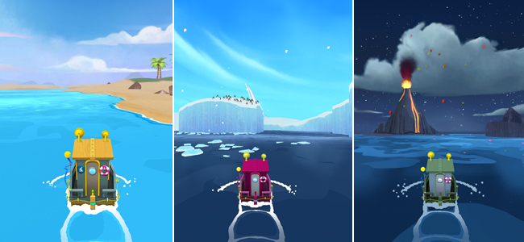
Figure 2: sea hero quest game,https://www.alzheimersresearchuk.org/our-research/what-we-do/sea-hero-quest/

- 2.2 Investigate the different types of dementia

- 2.2.1 Types of dementia

Clinical Pick’s disease or more commonly known as frontotemporal disease is a type of dementia that is often referred to being a diverse group of other conditions that collectively cause an onset of dementia (Warren, Rohrer & Rossor, 2013). Frontotemporal disease is also associated with other commonly known neurological diseases such as Parkinsonism and motor neuron disease (Warren, Rohrer & Rossor, 2013). Frontotemporal disease can also be sub-categorised into three types of frontotemporal diseases known as: Frontotemporal lobar degeneration which is the loss of memory in the patient’s language and speech (Warren, Rohrer & Rossor, 2013), a behavioural variant frontotemporal disease which can alter people’s behaviour and personalities (Warren, Rohrer & Rossor, 2013), and sematic disease making those diagnosed struggle with logic (Warren, Rohrer & Rossor, 2013). Due to the pathological complexity of the disease, this discovery of the different type of syndromes have only recently been studied (Warren, Rohrer & Rossor, 2013). Studies suggest that the age of patients who can develop the disease is disproportionate and symptoms can begin between the age of 30 and 90 (Warren, Rohrer & Rossor, 2013), although further studies suggest that symptoms normally begin at the age of 60 (Warren, Rohrer & Rossor, 2013).
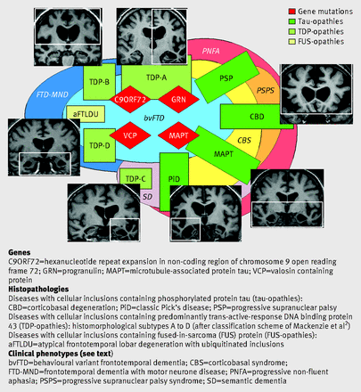
Figure 3: Molecular pathologies and phenotypic correlations in frontotemporal dementia (Warren, Rossor, 2013)
Majority of patients who develop dementia over the age of 65 tents to be diagnosed with vascular dementia (Miyoshi, 2009). Further studies suggest that vascular dementia is causing around 15% of all dementia cases (T O'Brien & Thomas, 2015). This is due to cerebrovascular disorders being age-related (Miyoshi, 2009). Although genetic abnormalities can facilitate from cerebrovascular disorders cause heredity vascular disorder which tends to occur in presenile patients (Miyoshi, 2009). Symptoms like short-term memory loss aren’t evident in vascular dementia until later stages of development (Miyoshi, 2009).
The most common cause of dementia is Alzheimer’s disease as it contributes to an estimated two-thirds of all dementia cases (Nussbaum & Ellis, 2003). Neurofibrillary tangles and extracellular senile plaques that contain peptide β amyloid are pathological hallmarks of Alzheimer’s disease (Nussbaum & Ellis, 2003).

- 2.2.2 Diagnosing dementia

When diagnosing dementia in patients a careful health evaluation examining their cognitive functions which include memory short/long term, language and visual capabilities (Lezak, Howieson, Loring & Fischer, 2004). Diagnostic procedures for dementia in patients are evaluated based on the results from clinical procedures such as neuropsychological pen-and-paper examinations (Lezak, Howieson, Loring & Fischer, 2004).
Diagnosing frontotemporal dementia can vary in difficulty due to the symptoms in the patient’s behaviour being like psychiatric disorder, this can often lead to misdiagnosis (Warren, Rohrer & Rossor, 2013). Due to the patient’s daily memory remaining intact (Warren, Rohrer & Rossor, 2013), the patient’s behaviour is studied closely, examining closely for changes in affection towards siblings and pets (Warren, Rohrer & Rossor, 2013), or any alternations to their table manners or food preferences (Warren, Rohrer & Rossor, 2013), and the sudden development of obsessions towards new hobbies or interests (Warren, Rohrer & Rossor, 2013). Cognitive assessments can also be conducted by an examiner to try and discover deficits of executive functions such as response inhibition and the formulation of strategy (Warren, Rohrer & Rossor, 2013). These examinations can be conducted through verbal fluency or cognitive estimates (Warren, Rohrer & Rossor, 2013). Magnetic resonance imaging (MRI) is used to search for asymmetric atrophies between the hemisphere of the frontal and temporal lobe (Warren, Rohrer & Rossor, 2013).
Vascular dementia can be rather difficult to diagnose early as previously stated symptoms like short-term memory isn’t evident until later development (Miyoshi, 2009). However, studying the patient’s medical history for haemorrhagic strokes and heterogeneity of vascular dementia can be used as a guide in evaluation (Román et al., 1993).
Similarly, when diagnosing Alzheimer’s dementia, it can be misdiagnosed easily as the reduction of cortical thickness and hippocampal volume are not only signs of Alzheimer’s disease but are also a normal part of aging (Fjell et al., 2014). Resulting in the diagnosis being based on neurologic examination as a definitive diagnosis can only be concluded by an autopsy (Nussbaum & Ellis, 2003).
- 2.2.3 Treatments in dementia

Studies based in Switzerland were taken place to discover the cost when treating people with dementia based on a yearly basis. When the study was concluded the estimate cost to treat one person within the comfort of their own home is between $7,100 - $68,000 US dollars per year depending on the severity of the patient’s dementia (Kraft, Marti, Werner & Sommer, 2010). Most severe cases of dementia require the patients must remain an institution for care, the cost of one person to be treated in an institution is between $23,900 - $49,000 US dollars (Kraft, Marti, Werner & Sommer, 2010). However, it must also be stated that the cost of being treated at home can also excel the amount previously stated due to home alternations being made to help the patient at home (Kraft, Marti, Werner & Sommer, 2010).
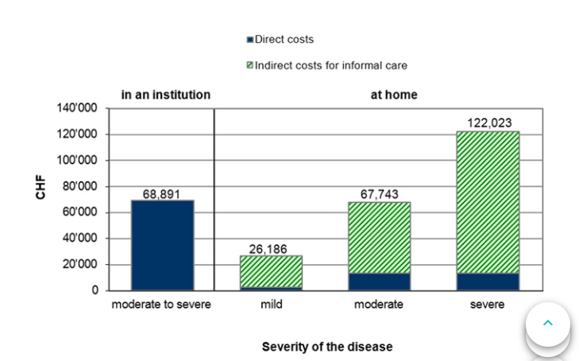
Figure 4: annual cost per person in 2007, differentiated by residential status and state of severity
Unfortunately, there are no current treatments that can alter the evolution of all types of frontotemporal dementia (Warren, Rohrer & Rossor, 2013). However, the use of speech therapy and set daily routines have shown evidence in slowing the rate of progression in the disease’s symptoms (Lau, Smit, Fleming & Riper, 2017).

Vascular dementia, unlike Alzheimer’s disease, has no licensed treatments as of 2015 (T O'Brien & Thomas, 2015). Despite the relation between cerebrovascular pathology and cognitive impairment is given the disease plausible tractable treatment (T O'Brien & Thomas, 2015). This is due to the uncertainties towards the disease classification and its diagnostics criteria (T O'Brien & Thomas, 2015). However, relations between vascular dementia and Alzheimer’s disease pathologies can be used as a guideline for future possible treatments (T O'Brien & Thomas, 2015).
Although Alzheimer’s disease has no treatments to alter the evolution of the disease studies suggest that polyphenol could possibly help in treating Alzheimer’s disease (Anekonda, 2006). Polyphenol is a mix of chemicals often found in plants and red wine is often used to treat patients against cardiovascular diseases and cancers (Anekonda, 2006). Although studies are unsure of its effects on Alzheimer’s disease, the disease’s pathology correlates to the mechanisms that are being treated by polyphenol in other diseases (Anekonda, 2006). Strongly suggesting that the use of polyphenols stilbenoids could be used in modulating Alzheimer’s disease pathomechanisms (Anekonda, 2006).

- 2.2.4 game mechanics for mental health

The game will be created on a PC and was intended to have participants playing on a virtual yacht, which is important as it will be used to test the participant’s awareness. The participant will then play 3 simple rounds flipping tiles to try and match the pictures to test the participant’s short-term memory and problem solving in between these rounds the participant will be asked cognitive estimate questions to gather data on their logical thinking (Warren, Rohrer & Rossor, 2013). Participants will be given a computer mouse that will vibrate as random times, when this happens the participant must press a button to stop the vibration, by doing this the participant’s sense of touch and reactions can be tested. While the participants are playing the game eye tracking software will be collecting information about the participant’s attention span.

- 3.0 Methods

The method section will explain the steps that must be completed for the project to be completed which in term will answer the question at the end. The development and the testing will be explained in detail along with the primary goals that must be completed.
- 3.1 Research method

Due to the purpose of the project is to have participants of an elderly age play a computer game to provide a diagnosis of dementia the game will be tested by comparing statistics from two different methods. One method is having the participants play the game allowing the game to collect data one the user and the second method is having the participant take a cognitive test conducted by an examiner easy for the participant to control and understand

- 3.2 Development of the game

With the project requiring participants of various ages, it is important that the game will be easily controlled and understood by the participants, because of this the participants’ experience design will be a major factor in developing the game for the project. This can be accomplished by following Schneiderman’s eight golden rules in user interface design. One of the issues will be following Schneiderman’s rule of reducing the short-term memory load as people can only remember a small amount of information (Shneiderman et al., 2016). This is difficult as the game is being used primarily to test the participant’s memory and awareness. Solutions to this will be to limit the amount of information being given to the participants but leaving subtle reminders on important pieces of information in the game. However, Shneiderman also states that in order to have a good user interface the game will have consistency in its interface (Shneiderman et al., 2016), this will not be the case for the project as part of the test is to test the participants logic and by making the user interface inconsistent with making the user interface different each level the participants will have to use logic and understanding more than if the levels were consistent.

- 3.3 Obtain assistance from medical professionals

Due to the second and evaluation part of the projects experiment requiring a professional dementia examiner, a letter asking for assistance has been issued to medical clinics that have memory treatment centres such as the Parkview medical memory clinic In Glasgow and elderly care homes.

- 3.4 Obtain participants

Due to the project testing for dementia participants would be preferably those will early stages of dementia, as it would make evaluating the accuracy of the game easier. This will also mean the specific procedures will have to take place to ensure ethics. One procedure would be that the participant’s guardian or caretaker will have to be present during the testing this also refers to the guardian or caretaker giving consent to allow the participant to take part in the test and having the right to top testing at any given time. Letters will again be distributed to care homes across Glasgow asking permission to experiment on the residents with the resident or resident’s guardian’s permission. A second procedure would be to have the participant attempt the experiment in a safe controlled environment
However, if no care homes wish to partake in the experiment then elderly aged participants from the public can also be obtained as the project’s game is targeted towards the majority of people who might get dementia which was previously stated that elderly people are most vulnerable to getting dementia resulting in the project’s game being designed to be easy to use by elderly people.
- 3.5 Gather and evaluate the data

Once the experiments have been conducted the data will be gathered and compared. After they have been compared the results should help in determining the accuracy of the hypothesis for the project and possible changes that could be made within the projects experiment in future iterations. This would have also helped in the poster presentation however the poster presentation is now cancelled due to unforeseen circumstances.

- 4.0 Development and execution

This section will be used to explain the development of the projects experiment and the execution of the experiment including any issues that may have been encountered and how they were solved.
The original concept for the project was to develop a computer game that could help doctors or nurses diagnosing their patients with dementia and conducting tests with the game by having elderly participants from a local elderly home with the assistance of the residents’ doctor and if required the participant’s carer or guardian/ power of attorney. The experiment would have been conducted in a controlled environment. Due to unforeseen circumstances and the occurrence of a countrywide lockdown due to the recent pandemic caused by COVID-19 the development and execution of the experiment for the project could not be taken place. As a result of this section will now explain the design of the game for the project and how it should be developed along with reasoning as to why these design choices have been taken. Concluding the theoretical results that the game should produce at the end of development.

- 4.1 Projects target audiences

Before the game can be designed for the project the target audience must first be established. Since the game in question is being developed with the intention to help doctors and nurses diagnose dementia in their patients. By looking at those who have dementia we can then create a design based on the average person diagnosed with dementia. As previously stated, the average age in which people begin to get symptoms of dementia is at the age of 60 (Warren, Rohrer & Rossor, 2013). Using this information, we can base our target audience on those over the age of 60 by doing this we can base the design of the game. However, this itself will provide problems as people over the age of 60 can not only have mental issues like dementia in which we are trying to diagnose but physical issues like failing eyesight as people over the age of 60 can suffer from age-related macular degeneration(Spires, 2006) and arthritis can become an issue as hand function can begin to decline at the age of 65(Carmeli, Patish & Coleman, 2003). These issues must be taken into consideration when developing a game for people over the age of 60.
- 4.2 Technology

As technology vastly grows, so does its purposes. This section will be discussing some technologies that are now being used in the gaming industry that can be used to help design a game that is meant to help nurses and doctors diagnose dementia in its patients. With mobile gaming increasing in popularity it also highlights the use of touchscreens in gaming. The use of touchscreens could be used to help in the development of a game for diagnosing dementia as the could provide a solution to users that develop arthritis. A study conducted by the Rheumatoid Arthritis Quality of life Questionnaire and the health assessment questionnaire found that out of the 95 patients 64% of them preferred the use of touchscreens to gather data instead of the traditional paper method because of its ease of use (Greenwood, Hakim, Carson & Doyle, 2006). However, a different study was made by Wang-chin Tsai and Chang-Franw Lee their study showed that elderly users took a longer time to adapt to high detailed icon feedback when using a touchscreen (Kobayashi et al., 2011) This will need to be taken into consideration when developing a touchscreen computer game for an elderly user by restricting how highly detailed the icons should be. Other technologies that can be used in the development of a game that is used to help diagnose dementia is integrating the use of eye tracking technology. In recent years eye tracking software has become much more affordable equipment and has been making strides within the gaming industry an evaluation of the new tobii eyex eye tracking software for gaming in 2016 showed that although it is still behind on the research grade high-cost eye tracking software the comparison is getting smaller as the technology is improving (Gibaldi, Vanegas, Bex & Maiello, 2017). Eye tracking technology is already tested to see if it can be used to help spot signs of dementia in people in 2009 using a mixture of people some with Parkinson’s disease the test had a picture displayed alongside a novel picture which is revealed after a 2 second or a 2 minute delay (Crutcher et al., 2009). The test showed that people with mild cognitive impairment only viewed the novel picture 53% of the time (Crutcher et al., 2009). While participants with Parkinson’s disease noticed the novel picture 70% of the time (Crutcher et al., 2009). These studies help show that eye tracking software is already being used in both gaming and in medical research for diagnosing dementia meaning that it could have the possibility to be combined into both.

- 4.3 Design concept

The original design of the game was going to be created using two monitors with one being touch screen for the user to use as the primary audience will be elderly this would be an easier control scheme for them to use to the traditional mouse and keyboard, as well as it helps measure the participants’ cognitive functions and reaction times when responding to the games feedback and the other monitor will be for the doctor or nurse to monitor the patient that is playing the game. Due to the game requiring an eye tracker the one originally going to be used was the Tobii eye tracker 4C the reason for using this eye tracker is due to the fact that this eye tracker was made specifically for gaming and is programmable through unity which also shows that unity is a good choice of gaming engine to use when creating a computer game for trying to diagnosing dementia. Each part of the game is designed to help the examiner spot a different sign of dementia in the participant. Another hardware requirement would be a standard webcam that can be set upon the monitor to record the participant to allow the examiner to look at how the participants handled the game. This is also advantageous to the examiners as having a recorded session can be sent away to another examiner for a second opinion.

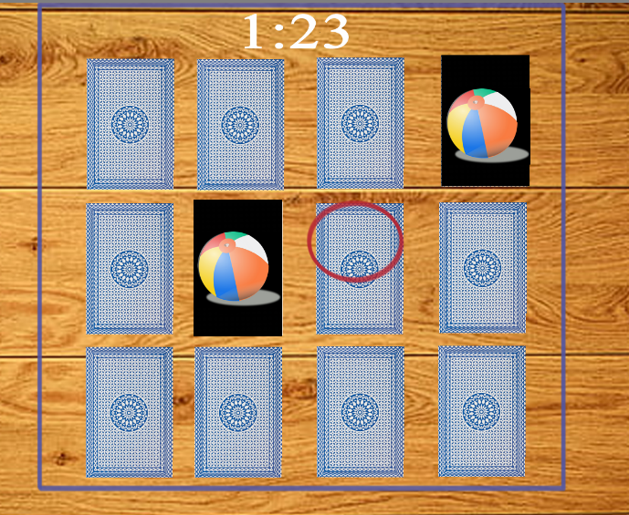
Figure 5 game design concept part 1

The game will consist of three parts, the first part of the game will have the user take part in a simple 4 x 3 card matching card game where the user will have 3 minutes to match each card using the touch screen monitor. This will help in showing the users short term memory. As the user is playing the eye tracking software (shown as the red circle in the image above) is a recording of which the user is paying attention to in order to provide data for the doctor or the nurses to analyse. This is done by having the eye tracker connected to a timer that will go off either if the eye stays in one place longer than 3 seconds or if the user’s eyes leave the boundaries of the game represented in the image above by the blue border. This is done to represent the user’s attention level for example if the timer was high it would indicate that the user is distracted and not engaging in the activity. Overall, the first part of the game is used to measure short term memory and attention span. A symptom that is commonly found in all types of dementia.

The scoring system for part one is simple for every correct match they get a point added to their score and if they make a mistake a point is added to an error counter. At the end of the session, these scores will be shown to the examiner along with the total time the participant may have been distracted and the time it took for the participant to complete the task in order to help determine the results of the participant for this part of the game.
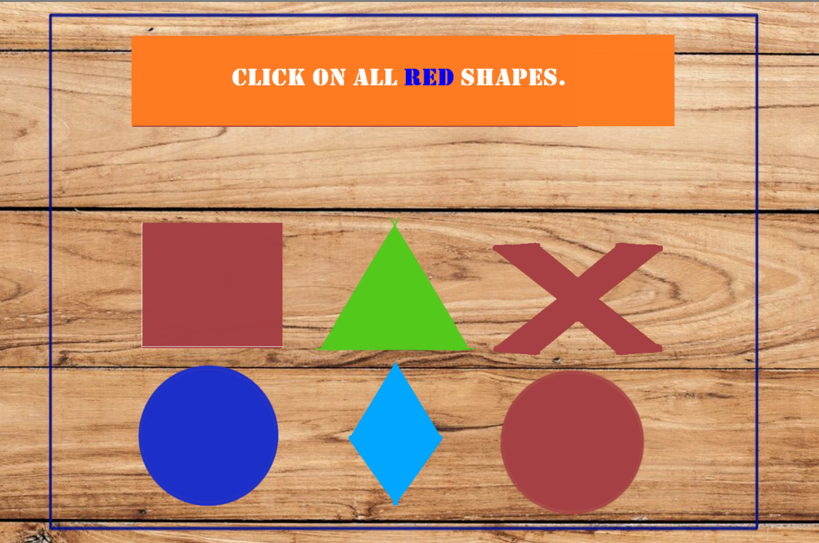
Figure 6 game concept design part 2
The second part of the game has the user perform simple tasks instructed by the game as the image above shows this will help the patient’s examiner see how well the patient’s knowledge and understanding are when performing simple everyday tasks and basic problem solving as people with signs of dementia would often struggle in. The game will then send the results of the playthrough to the examiner showing any mistakes the patients may have made and the time it took them to perform the tasks giving to them. Much like the previous part of the game the eye tracker will be used to measure the patient’s attention to the game. This is where we might see an increase in the timer with the patient’s eyesight staying in the one spot due to trying to the patient trying to understand how to complete the task the computer game has given them. It must also be noted in the image above that although the task asks for all the red shaped the word red is highlighted in blue this is also done to test the patient’s understandings and basic problem solving. this is due to a patient that is struggling with a basic understanding and problem solving is one of the main symptoms that can in dementia and most commonly vascular dementia as other symptoms such as short term memory loss do not occur until the disease has evolved to a later stage of development (Miyoshi, 2009).

The scoring system for part 2 is like the scoring system in part one where the participant will gain a point for every correct selection and a point will go to the error counter if the participant selects the wrong icon in this section. Along with the completion time and total distraction time for this section of the game.
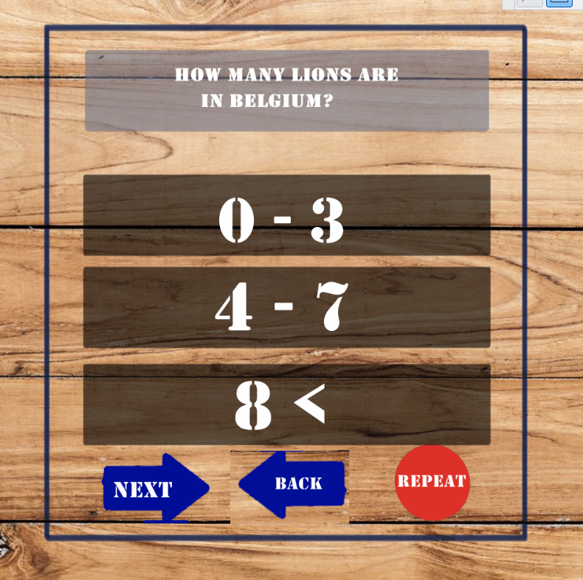
Figure 7 game concept design part 3
The third and final part of the game would have the participant answer 5 simple logic questions like ones already being conducted by doctors in medical practice. This is because one of the signs of dementia is the declining ability of the patients logical thinking more specifically this is one of the symptoms found in frontotemporal dementia (Warren, Rohrer & Rossor, 2013). However, after each question is asked the arrangement of the navigational bar demonstrated in the image above will change for example the next arrow button could swap positions with the repeat question button, although this contradicts with one of Schneiderman’s 8 golden rules of user interface design by having a lack of consistency (Shneiderman et al., 2016). This done intentionally to make the participant think more logical in understanding the navigation of the computer game’s quiz testing the participant’s logical think further than traditional pen and paper tests already being conducted in medical practices. It should also be stated that the back button although sends the participants back to the previous question or remain where it is if the participant is at the 1st question it serves no purpose to the participants as they cannot change their answer. This button is to allow error in this part of the game by having the participant fail incorrectly navigating through the quiz. It should also be noted that like the other two parts the eye tracker will still be keeping track of the participant eye movements.

The scoring system for this section of the game is considerably more complex as trying to add a score to logical thinking can seem impossible and the quality of the results could be argued due to an individual’s opinion. However, for this project, the scoring system created for this part of the game has been made as simple as possible and serves only as a guideline for the examiner. Each question that is asked with have a possible 3 answers these 3 answers can be separated into categories: good answer, middle answer and bad answer. The good answer is what could be argued to be the most logical answer to most, using the example above picking between 0-3 as the answer to how many lions are in Belgium giving that Belgium has no real habitable areas for wild lions, this would award the participant 3 points. A middle answer would be the next most logical option which in this case would be the participant picking between 4-7 with the argument that the lions could be in a zoo in Belgium, this would result in the participant receiving 2 points. The bad answer being arguable the worse logical answer the participant could pick in this case would be 8 or more lions would result in the participant receiving only one point. However, as stated previously the back button is being used in the section of the game as a means of counting errors but instead of having a separate counter for the errors as none may occur making an error in this section subtracts a point from the participant’s score. This does leave the possibility that the participant can get a negative score if the participant makes numerous errors but if this is the case it can be determined as a logical and navigational error within the participant which is what this section of the game is trying to find or severe human error this will have to be determined by the examiner

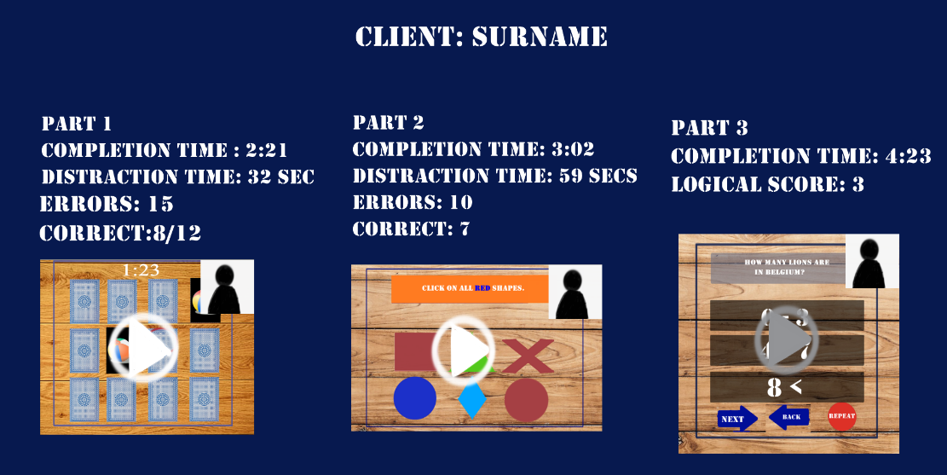
Figure 8 game design concept doctors screen
Once the full game has been completed by the participant the examiner will receive a final scoring screen. This screen allows the examiner to go back and watch the recording of both the participant’s facial responses and watch their interactions with the game. The game also breaks down the times and scores of each section in the game allowing the examiner to determine which symptoms the participant may be showing. Using the image above as a theoretical example despite failing to complete the memory test in the first part of the game the biggest cause of concern would be the result of the third example from taking so long to complete this section to the very low score the participant received we can hypothetically determine that their navigational and logical thought processing is severely lacking. This could then lead the examiner to the evaluation that this particular participant is suffering from a type of Frontal temporal dementia as the participants struggle with logic is clearly apparent in the failure of completing the memory test shows signs of Frontotemporal lobar degeneration (Warren, Rohrer & Rossor, 2013). Due to the inability to conduct real tests, all numbers and statements made by these examples are all hypothetical at this moment in time.
- 4.4 Testing

As previously stated, due to the unfortunate outcome of the coronavirus the development and testing of the project’s experiment could not have taken place as a result of a nationwide lockdown meaning that the required participants for the experiments being elderly citizens could not be obtained and using younger aged citizens may produce the desired results however this will not provide accurate legitimate results. Although we might not be able to test the game itself for accurate results, the software and hardware that could be used in the game development can be tested to show their effectiveness and whether or not they are viable for the project. One of the projects biggest concerns was the use of the eye tracker. As this test is checking the effectiveness of the technology the participants required will not need to be elderly as we are not trying to find the eye trackers ease of use but its quality of data collection.
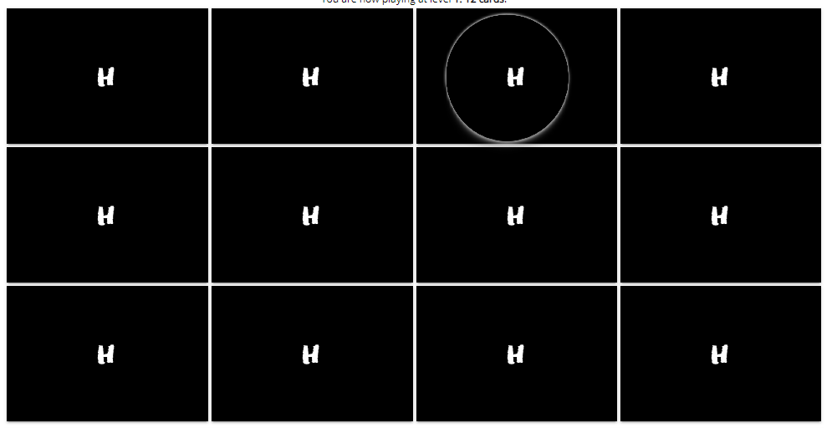
Figure 9 Basic memory game with eye tracker and touchscreen
The test has the participant play two simple card flipping memory games using both the eye tracker and touchscreen monitor with the first game being a 3x4 grid and the second game being a 6x6 grid. The purpose of this test was to check the accuracy of the eye tracker. Using the 3 available participants on site the eye tracker’s capabilities were shown to be accurate to a certain extent. The eye tracker shows what the user is staring at by highlighting the area with a circle as seen in the images above. However, as the size of the grid increases the image size of the cards must decrease in order to show all the cards on screen at once and as the eye tracker’s circle stays the same size this presents issues in accurately telling which card the user is staring at due to multiple cards being able to fit inside the eye tracker’s circle. In order to get the most accurate results in the eye tracker, the images in the project’s experiment must be large enough that the eye tracker’s circle can fit within the image thus supporting the design concept of having the card grid 4x3.

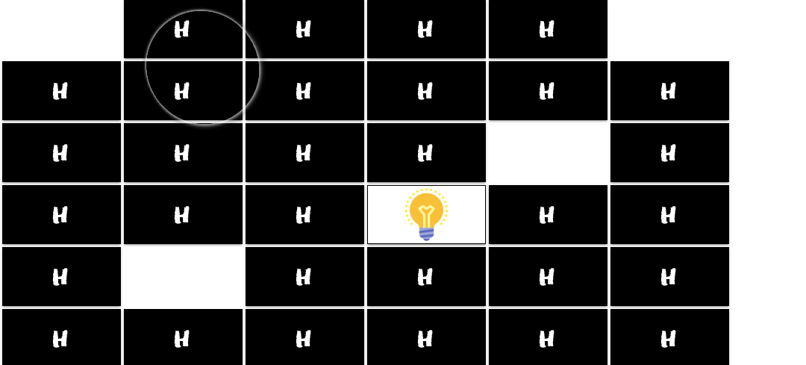
Figure 10 memory game 6x6 grid with eye tracker
The test was made using the Tobii Eye Tracker 4c and the reason for highlighting what type of eye tracker is being used is due to its set up. The Tobii Eye Tracker 4c is a commercial use gaming eye tracker meaning that its affordable and easy to use however the eye tracker camera itself must be fitted on the bottom of the monitor and nowhere else. This presented issues when testing the eye tracker with the touchscreen as quite often the participant’s arm would cover the eye tracker’s camera meaning the eye tracker could not track the participant resulting in a loss of data. To calculate the amount of data lost because of this the participant’s were timed when playing the larger grid and timing how long the eye tracker would lose track of the participants eyes.
 | Game Time(sec) | Tracker Down Time (sec)
User1 | 270.42 | 36.1
User2 | 239.47 | 36.64
User3 | 300.12 | 45.59

Results showed that when the participants are playing the memory game the eye tracker would lose track of the participant’s eyes an average of 12% of the participant’s total playtime. This highlights the issue of using an eye tracking camera placed under a touch screen monitor as the participants using the touchscreen can obscure the eye tracking camera. Possible solutions to this could be using an alternative eye tracking software in which the eye tracking camera can be placed on top of the touchscreen monitor in order to prevent participants from obscuring the camera reducing in the loss of possibly vital data.
The projects design concept states that the eye tracking camera will also measure if the participants are distracted by checking if the participant’s eyes are staying in the same position for an extended period. In order to test whether this is the case or not the same 3 participants from the previous test where asked to stare a red dot at the centre of the screen for 60 seconds.
Figure 11 red dot screen test
The point of this experiment is to prove that when the participant begins to lose attention the eye trackers circle should stay in position for an extended period. However, when tested it was discovered that when the participant begins to lose their attention span their eyesight begins to slowly and gradually drift to the side. This means the design concept of the eye tracker is able to tell if the participant is being distracted by not moving their eyes. A solution to this would be to have the eye tracker set the timer to begin counting if the eye trackers circles movement speed is below average which for a certain amount of time this could then be taken as the participant losing attention.

- 5.0 Conclusion

This section will explain possible future improvements that could be made when developing a game in detecting dementia and an overview of the project explaining what went well and what could have been done differently in the project and how these changes would have changed the outcome of the project.
- 5.1 Possible improvements

As previously stated, due to the unforeseen circumstances of COVID-19 the original experiment could not be tested. Without the results from the original experiment stating possible improvements that could be made towards the experiment for the project is rather difficult. However, given the information received from testing the combination of the touchscreen and the Tobii Eye Tracker 4c in its own separate experiment has shown that despite the eye tracker’s accuracy due to its positioning being under the touchscreen monitor the loss of vital data from participants accidentally covering the camera when using the touchscreen it can be stated the this would have the same effect in the original experiment for the project meaning the use of a different eye tracking camera in which the positioning of the camera could be placed above the touchscreen monitor would provide an improvement in collecting data for the original project’s experiment. When designing the original concept for the experiment the participant would have been given a wrist band to wear that would vibrate allowing the examiner to assess the participant’s sense of touch as nerve receptors fading can be seen as a possible sign of dementia. But upon further evaluation, the use of a wrist ban was problematic as it could irritate the user causing them discomfort, as a result, the implementation of a vibrating wrist band was scraped from the project’s experiment. Although it may be possible to still simulate this in future iterations with having the screen possibly vibrate when touched which would be less irritating for the participants and allow the examiner to gather more data providing better assistance in diagnosing dementia which would be making an improvement to the project’s experiments.
- 5.2 Conclusion

Due to the inability to conduct the original project’s experiment in finding the viability and usability of serious games in assisting the diagnosis of dementia in patients because of unforeseen circumstances of a global pandemic the results of whether or not the use of serious games is a viable alternative to assisting the medical profession in diagnosing dementia in patients until the original experiment can be carried out and the data analysed the results can only be estimated by comparing the results of the experiments testing the equipment for the games design concept like the experiment to test the accuracy of the eye tracker and comparing them to studies that have been made in the literature review. Although the reasoning for the design choices can be explained throughout the literature, the testing of the equipment has shown that further improvement on the equipment such as the eye tracker must be made before further studies can be accurately conducted. It must also be stated that this project does not highlight all types of dementia either does it explain all symptoms of dementia because of this the project’s experiment could not be designed to diagnosis dementia with 100% accuracy as the project’s game could not detect every possible symptom. Overall by comparing the results from the equipment test with the literature review it can be neither agreed or disagreed as to whether or not serious games can be a viable and usable alternative in assisting the medical profession in helping but when compared to the traditional method of testing used in today’s modern medicine must be further researched in order to find a defining conclusion.

References
JOHNSON, W.L., 2007. Serious use of a serious game for language learning. Frontiers in Artificial Intelligence and Applications. 158, pp.67.
WINBLAD, B., AMOUYEL, P., ANDRIEU, S., BALLARD, C., BRAYNE, C., BRODATY, H., CEDAZO-MINGUEZ, A., DUBOIS, B., EDVARDSSON, D. & FELDMAN, H., 2016. Defeating Alzheimer's disease and other dementias: a priority for European science and society. The Lancet Neurology. 15(5), pp.455-532.
VALLADARES-RODRIGUEZ, S., FERNÁNDEZ-IGLESIAS, M.J., ANIDO-RIFÓN, L., FACAL, D. & PÉREZ-RODRÍGUEZ, R., 2018. Episodix: a serious game to detect cognitive impairment in senior adults. A psychometric study. PeerJ. 6, pp.e5478.
ROJAS, G., BARTOLONI, L., DILLON, C., SERRANO, C.M., ITURRY, M. & ALLEGRI, R.F., 2011. Clinical and economic characteristics associated with direct costs of Alzheimer's, frontotemporal and vascular dementia in Argentina. International Psychogeriatrics. 23(4), pp.554-561.
HARVEY, R.J., SKELTON-ROBINSON, M. & ROSSOR, M.N., 2003. The prevalence and causes of dementia in people under the age of 65 years. Journal of Neurology, Neurosurgery & Psychiatry. 74(9), pp.1206-1209.
O’SHEA, D.M., DE WIT, L. & SMITH, G.E., 2019. Doctor, should I use computer games to prevent dementia?. Clinical Gerontologist. 42(1), pp.3-16.
MCDERMOTT, A., 2013. A comparison of two video game genres as cognitive training tools in older adults.
LAU, H.M., SMIT, J.H., FLEMING, T.M. & RIPER, H., 2017. Serious games for mental health: are they accessible, feasible, and effective? A systematic review and meta-analysis. Frontiers in Psychiatry. 7, pp.209.
KWON, J. & LEE, Y., 2016. Serious games for the job training of persons with developmental disabilities. Computers & Education. 95, pp.328-339.
EKLUND, L., 2016. Who are the casual gamers? Gender tropes and tokenism in game culture. Leaver, T.‒Willson, M.(Eds.), Social, Casual and Mobile Games: The Changing Gaming Landscape.Bloomsbury Academic. , pp.15-29.
WARREN, J.D., ROHRER, J.D. & ROSSOR, M.N., 2013. Frontotemporal dementia. Bmj. 347, pp.f4827.
MIYOSHI, K., 2009. What is ‘early onset dementia’?. Psychogeriatrics. 9(2), pp.67-72.
T O'BRIEN, J. & THOMAS, A., 2015. Vascular dementia. The Lancet. 386(10004), pp.1698-1706.
LEZAK, M.D., HOWIESON, D.B., LORING, D.W. & FISCHER, J.S., 2004.Neuropsychological assessment. Oxford University Press, USA.
ROMÁN, G.C., TATEMICHI, T.K., ERKINJUNTTI, T., CUMMINGS, J.L., MASDEU, J.C., GARCIA, J.H., AMADUCCI, L., ORGOGOZO, J., BRUN, A. & HOFMAN, A., 1993. Vascular dementia: diagnostic criteria for research studies: report of the NINDS‐AIREN International Workshop. Neurology. 43(2), pp.250.
KRAFT, E., MARTI, M., WERNER, S. & SOMMER, H., 2010. Cost of dementia in Switzerland. Swiss Medical Weekly. 140(3536).
FLEMING, T.M., DE BEURS, D., KHAZAAL, Y., GAGGIOLI, A., RIVA, G., BOTELLA, C., BAÑOS, R.M., ASCHIERI, F., BAVIN, L.M. & KLEIBOER, A., 2016. Maximizing the impact of e-therapy and serious gaming: time for a paradigm shift. Frontiers in Psychiatry. 7, pp.65.
FJELL, A.M., MCEVOY, L., HOLLAND, D., DALE, A.M., WALHOVD, K.B. & ALZHEIMER'S DISEASE NEUROIMAGING INITIATIVE, 2014. What is normal in normal aging? Effects of aging, amyloid and Alzheimer's disease on the cerebral cortex and the hippocampus. Progress in Neurobiology. 117, pp.20-40.
NUSSBAUM, R.L. & ELLIS, C.E., 2003. Alzheimer's disease and Parkinson's disease. New England Journal of Medicine. 348(14), pp.1356-1364.
ANEKONDA, T.S., 2006. Resveratrol—a boon for treating Alzheimer's disease?. Brain Research Reviews. 52(2), pp.316-326.
HYDE, M., SCOTT-SLADE, M., SCOTT-SLADE, H., HORNBERGER, M., SPIERS, H., DALTON, R., HOELSCHER, C., WIERNER, J. & BOHBOT, V., 2016. Sea Hero Quest: The World’s first mobile game where anyone can help scientists fight dementia.
COUGHLAN, G., LACZÓ, J., HORT, J., MINIHANE, A. & HORNBERGER, M., 2018. Spatial navigation deficits—overlooked cognitive marker for preclinical Alzheimer disease?. Nature Reviews Neurology. 14(8), pp.496-506.
Sea hero quest game,https://www.alzheimersresearchuk.org/our-research/what-we-do/sea-hero-quest/
SHNEIDERMAN, B., PLAISANT, C., COHEN, M., JACOBS, S., ELMQVIST, N. & DIAKOPOULOS, N., 2016. Designing the user interface: strategies for effective human-computer interaction. Pearson.
SPIRES, R.A., 2006. How you can help when older eyes fail: an aging population means more of your patients will have a condition that may severely compromise their eyesight. This quick review will help improve your care. Rn. 69(2), pp.38-45.
CARMELI, E., PATISH, H. & COLEMAN, R., 2003. The aging hand. The Journals of Gerontology Series A: Biological Sciences and Medical Sciences. 58(2), pp.M146-M152.
GREENWOOD, M.C., HAKIM, A.J., CARSON, E. & DOYLE, D.V., 2006. Touch-screen computer systems in the rheumatology clinic offer a reliable and user-friendly means of collecting quality-of-life and outcome data from patients with rheumatoid arthritis. Rheumatology. 45(1), pp.66-71.
KOBAYASHI, M., A. HIYAMA, T. MIURA, C. ASAKAWA, M. HIROSE & T. IFUKUBE. , 2011.Elderly user evaluation of mobile touchscreen interactions In:Anonymous IFIP Conference on Human-Computer Interaction, Springer, pp.83-99.
GIBALDI, A., VANEGAS, M., BEX, P.J. & MAIELLO, G., 2017. Evaluation of the Tobii EyeX Eye tracking controller and Matlab toolkit for research. Behavior Research Methods. 49(3), pp.923-946.
CRUTCHER, M.D., CALHOUN-HANEY, R., MANZANARES, C.M., LAH, J.J., LEVEY, A.I. & ZOLA, S.M., 2009. Eye tracking during a visual paired comparison task as a predictor of early dementia. American Journal of Alzheimer's Disease & Other Dementias®. 24(3), pp.258-266.

Appendices

The approved signed hard copy of this form is held by the honours project Co-ordinator, David Moffat.
David Moffat
Viability and usability of computer games in diagnosing dementia
Computer games (design) 2019-2020
Jamie Adam
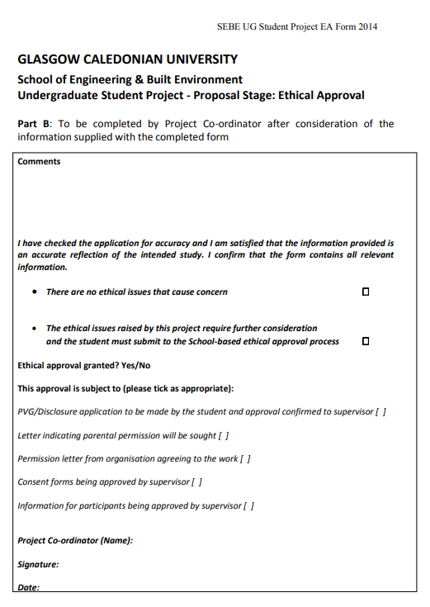
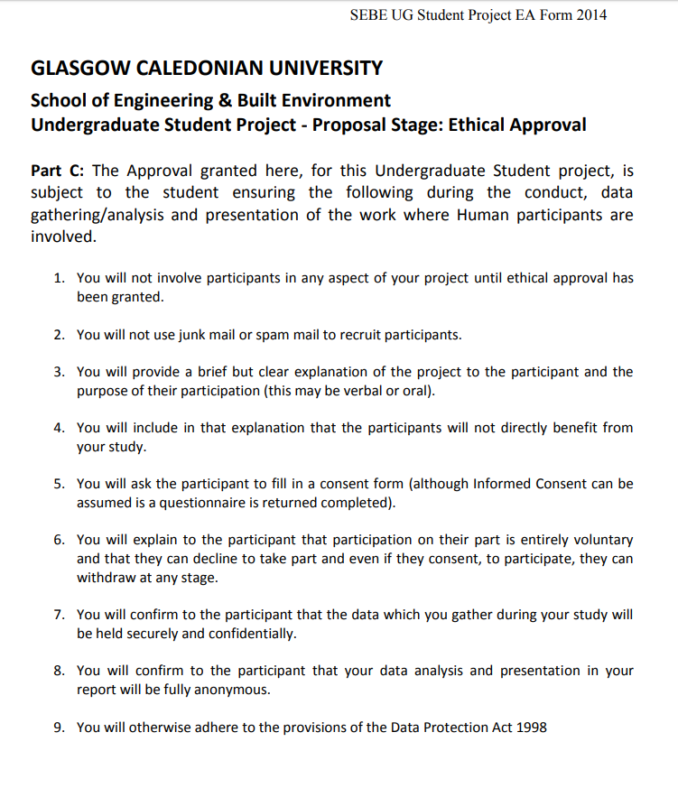

Signed by Student:___________________ Date: 20/04/2020

